For the complete code please make sure to contact me, you will find this is partially complete.

Homepage for e-commerce website with shopping cart to buy products online using paypal sandbox for testing payments. 

Featured products section to see relevant productsProducts with price and rating description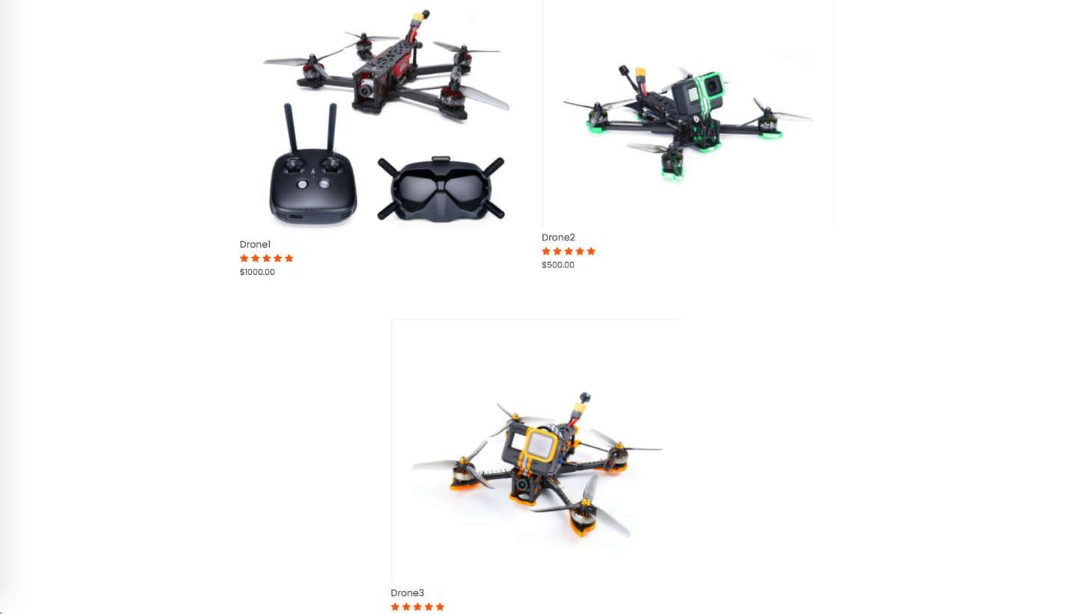

Section to feature an exclusive product and comments with rated productsWebpage Footer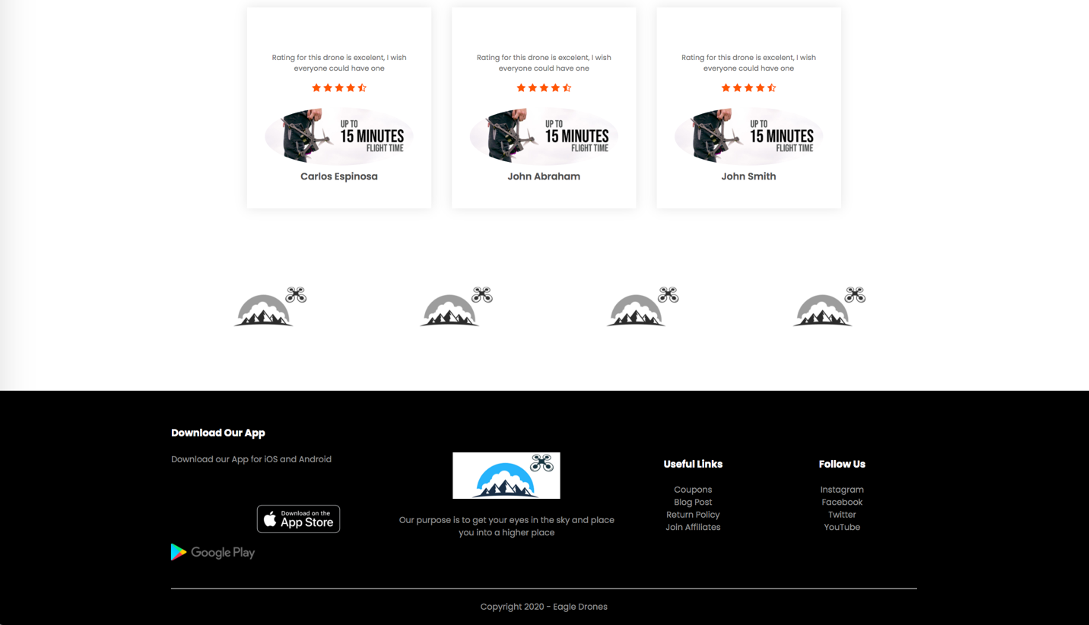

Products tile header with all products for display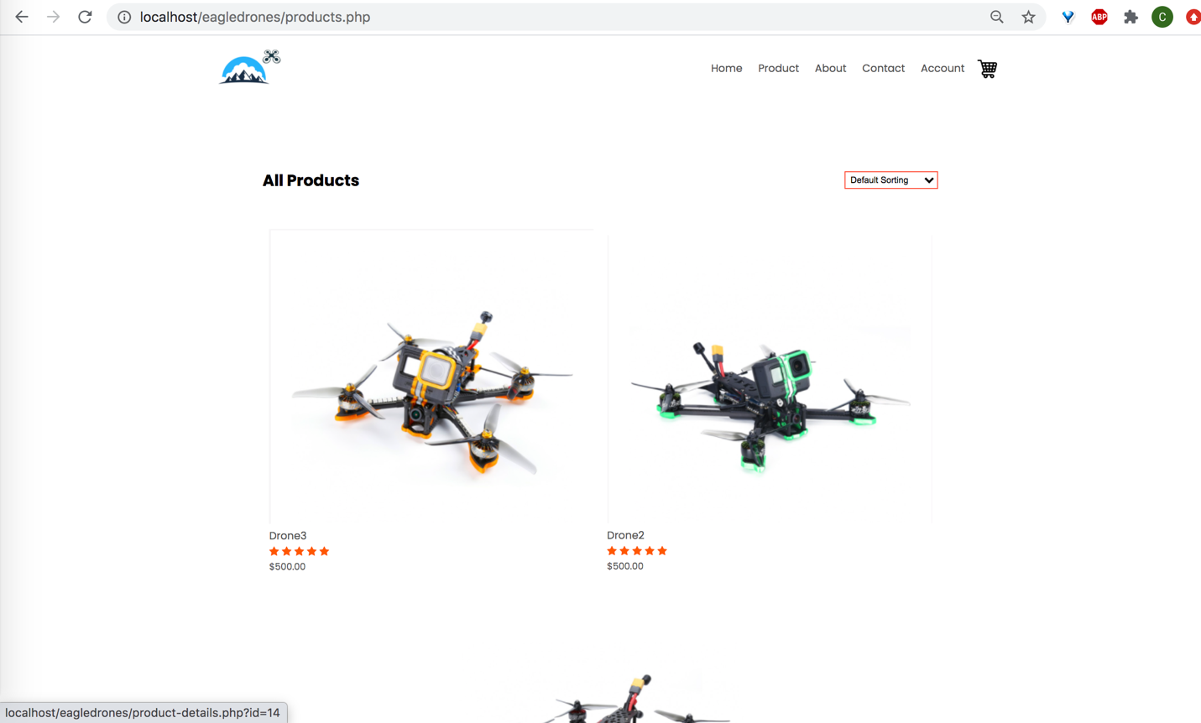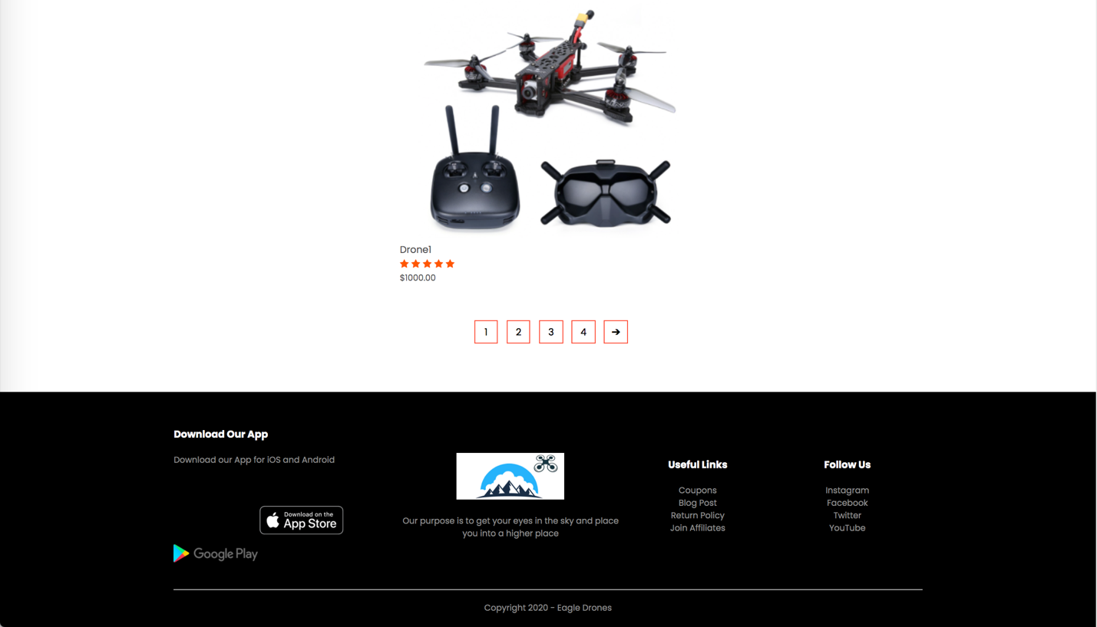

Register page to set up an account within company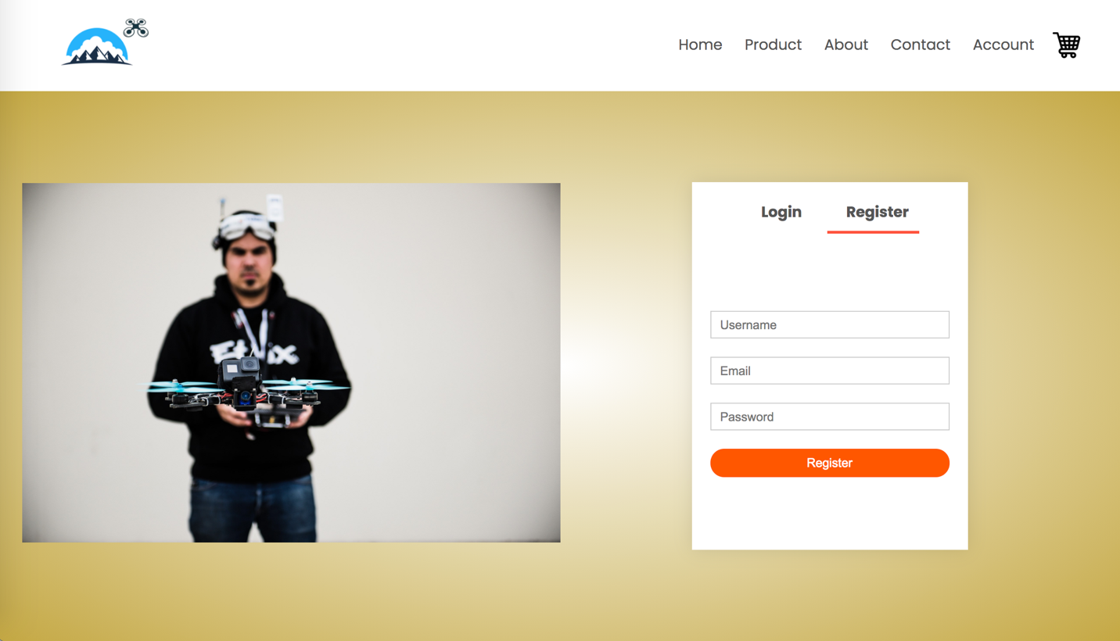 

Log in page with username or email and password 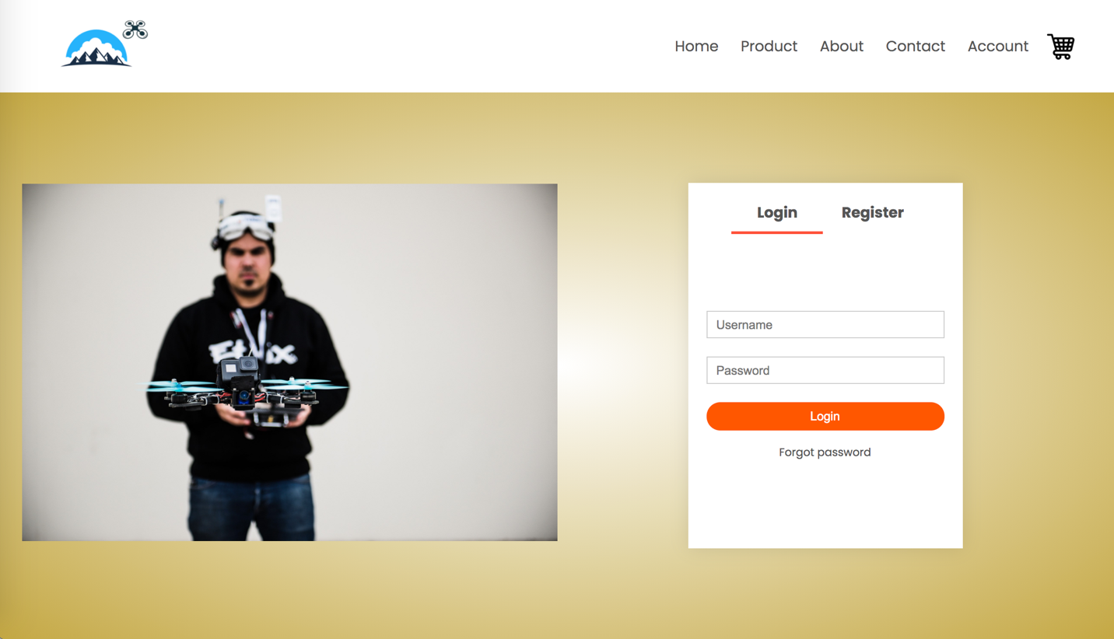

Product details page before adding to cart with option to select product quantity.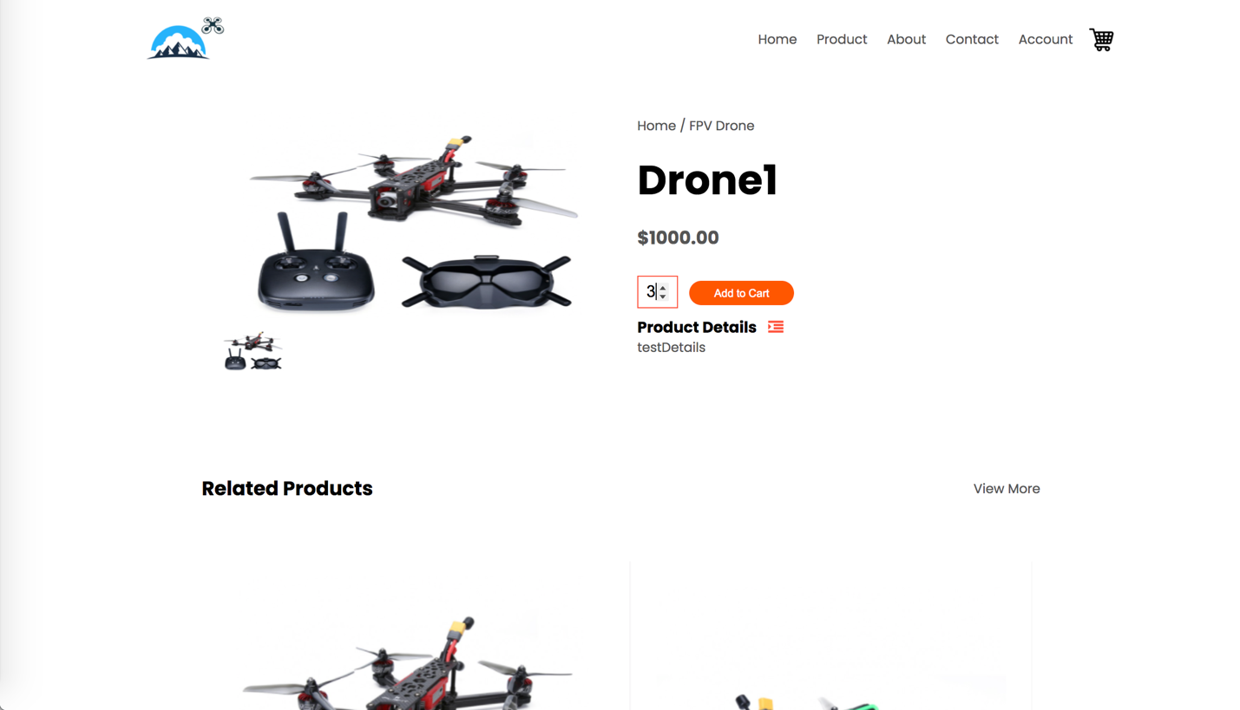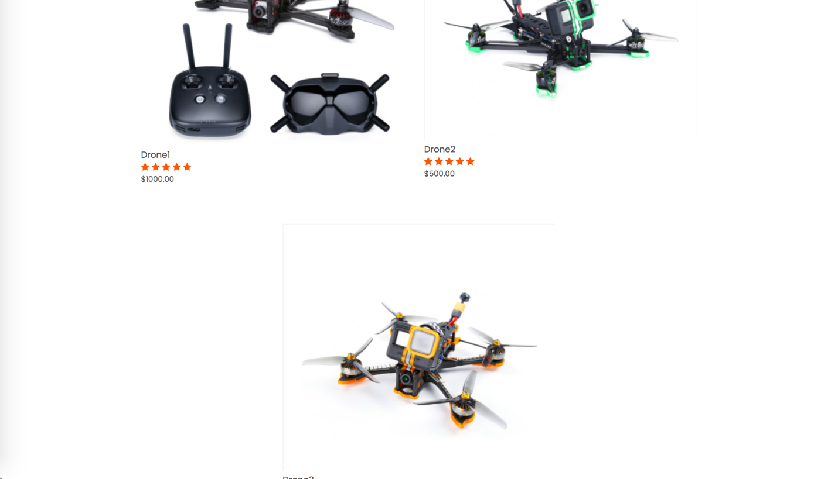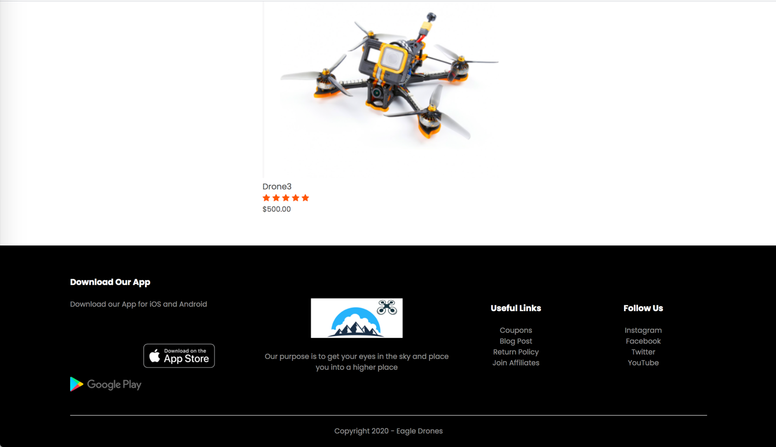

Shopping cart page with option to increase quantity and remove product. Ability to visit multiple pages and add more products if desired and edit quantities. Pay now button to continue payment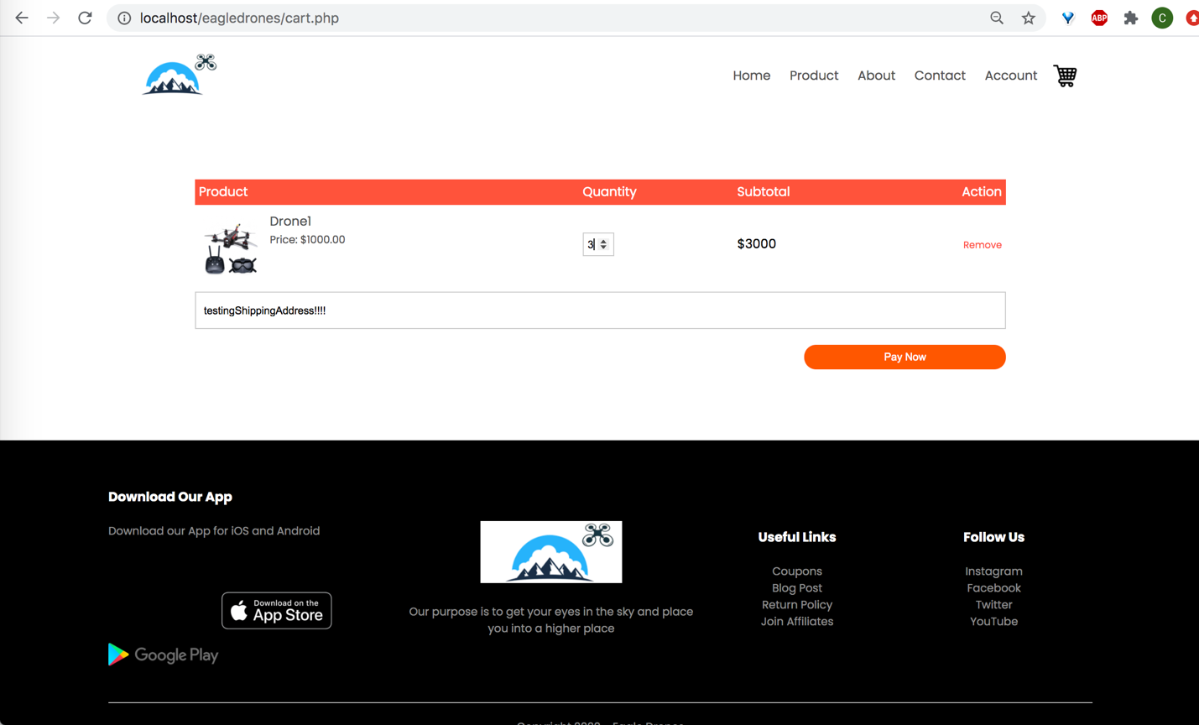

Method of payment and order total amount

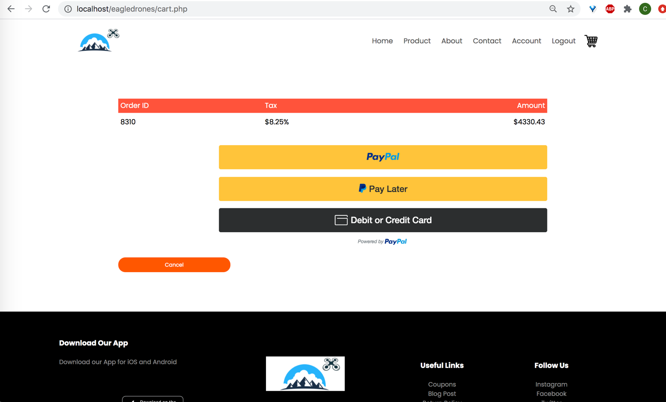

Admin inventory products view page with product id, title, amount, quantity, status, and action. Ability to increase and decrease quantity, remove product from inventory, and manage visibility of products.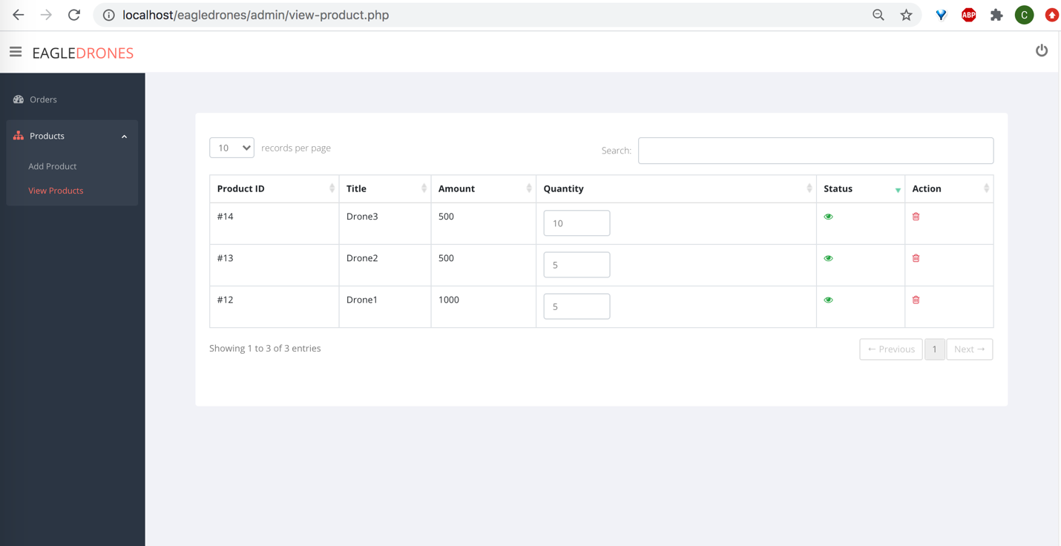

Add products page to add a product into inventory by updating title, amount, quantity, details boxes and add a picture of the product to be added. Save button to store product into company database.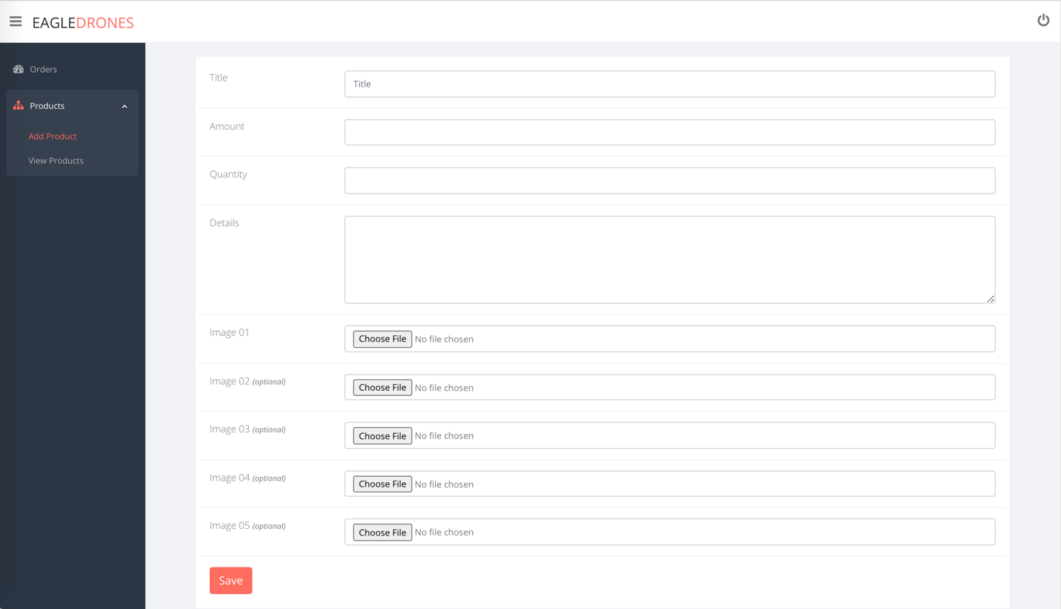

Order details page displaying username, ordered, productid, quantity, total payment and the ability to remove any order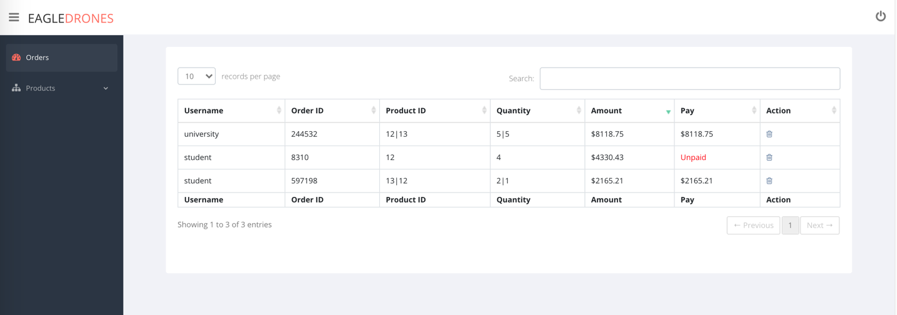

PhpMyAdmin database and tables

